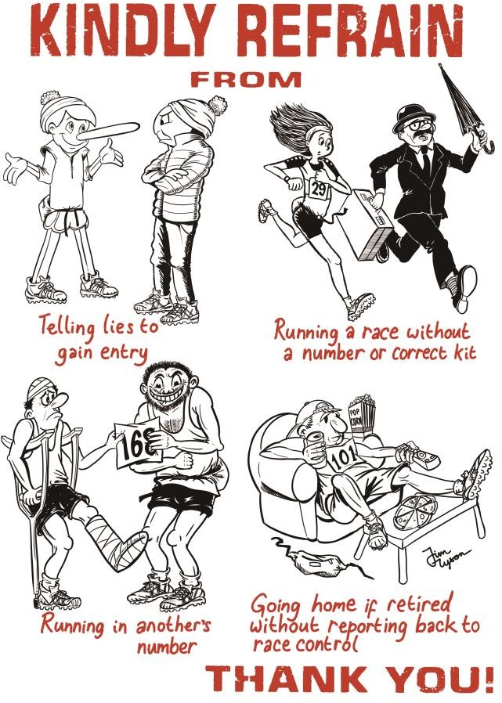FRA NON-MEMBERS

PLEASE TAKE NOTE OF THE FOLLOWING:

How to join the FRA?
Go to the FRA website at fellrunner.org.uk and follow the links
We look forward to welcoming you to the FRA!
Support your sport – Join the Fell Runners Association!
- 3 x Fellrunner magazines a year, plus Handbook and Race Calendar
- Priority entry to English Championship races and other FRA races
- Navigation and First Aid courses at subsidised rates
The FRA organises the English Fell Championships and the Annual Dinner and Awards
Race No.
SENIOR RACE ENTRY FORM 2026

Race: Minimum age to enter: Full Name: Club:
of Birth: Age |  | FRA NON-MEMBER

Date
______________
Email Address (optional):

Category (Please circle)
For U21 and U23 check whether to use age on day or age at 31st December

FEMALE | FU20 | FU23 | FSEN | F40 | F45 | F50 | F55 | F60 | F65 | F70 | F75
MALE | MU20 | MU23 | MSEN | M40 | M45 | M50 | M55 | M60 | M65 | M70 | M75

Address:
Postcode: Phone No: Vehicle Registration: Emergency Contact Name: Phone No:
- I accept the hazards inherent in fell running and acknowledge that I am entering and running this race at my own risk.
- I confirm that I am aware of the rules imposed on me by the Race Organiser and that I will comply with them.
- I confirm that I have read, and will comply with, the FRA “Requirements for Runners”, and especially the “absolute no-nos” of fell running.
- I acknowledge and agree that I am responsible for determining whether I have the skills equipment and fitness to participate in this event.
- I accept that neither the Race Organiser nor the Fell Runners Association shall be liable to me for any injury, loss or damage of any nature to me or my property arising out of my participation in this race (other than in respect of death or personal injury as a result of their negligence).
- I consent to publication of my name, club, race category, race number, finishing time and race position in race pre-entry and results lists, and to the sharing of all the above details with trusted partner organisations (e.g. UK Athletics) for disciplinary purposes or otherwise where necessary in the interests of the sport.

Signed: Date
Competitor or, if under 18, Parent/Legal Guardian or refer to Parental Consent Form

