**2024 Fell Runners Association U17 Development Camp**

**Introduction to International Mountain Running**

**17th March 2024, 10:00 – 16:00**

**Sedbergh**

This year’s U17 camp is planned for Sunday, March 17 in Sedbergh. As ever the camp is aimed at junior runners’ development, developing skills and knowledge, avoiding the traps and learning from the experience of others who have come through the junior ranks and then excelled as seniors as well as coaches, sports scientists and physiotherapists who are familiar with junior development and international competition.

Sessions will be led by Scout Adkin, Amelie Lane, Renee McGregor, Alasdair Russell, Alan Buckley and GB Chair Anne Buckley facilitated by England Chair Duncan Richards

**Cost and eligibility criteria.**

There will be a nominal fee of £10 for attendance, this does not include lunch.

To attend, athletes must be between 14 -16 and intend racing in the FRA U17 age group.

Athletes should have demonstrated ability by:

1. *placing in the top 10 in any FRA English Championship race*
2. *placing consistently in BOFRA races*
3. *reaching county level at cross country*
4. *or running fast times on the track or road*

So if you would like to apply for a place, please contact **duncan@intouchltd.co.uk** for an application form.

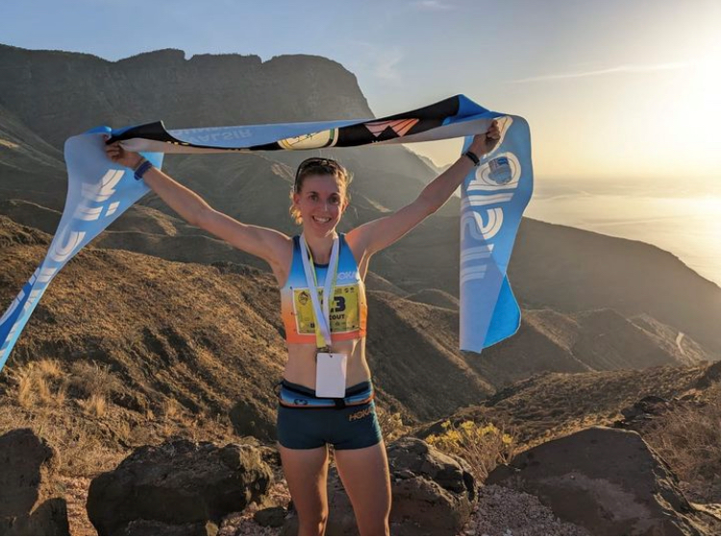

**Key speaker** – Representing Great Britain on the mountains since 2021, 8th in the Vertical uphill and 12th in the Classic up and down at the 2023 World Mountain Running Championships at Innsbruck. 2nd overall in the 12 race 2023 Valsir Mountain Running World Cup series, winning the Vertical Uphill title and coming 3rd in the classic series plus 2023 Scottish Cross Country Champion.

With World and European Championship Gold, Silver and Bronze medals from 2022 in Spain and Thailand physiotherapist and elite mountain runner, **Ambleside ACs** **Scout Adkin.**

**Junior Athlete Speaker** – From her first overseas international race for England in Saluzzo, Italy in 2022, coming 7th and helping the team collect team Gold, to representing Great Britian U20 in El Paso, Spain at the European Championships **the same year coming 10th and gaining team silver. To in 2023, winning the English Schools Fell Running title, then coming 3rd at the U18 Cup in Annecy also getting bronze as a team, and to the World Championships in Innsbruck coming 4th winning team Gold. Also enjoying cross country, starting 2024 as Yorkshire U20 cross country champion, Wharfedale Harries – Amelie Lane.**

**Sports Therapist – Kendal ACs - Alasdair Russell**.

Alasdair has been helping people, athletes in particular, to get back to their best following injury ever since graduating from UCLAN with a BSc (Hons) in Sports Therapy in 2011. A highly skilled and respected practitioner of manual therapy, massage and personalised rehabilitation regimes/programmes, Alasdair specialises in lower limb injuries typical of running, treating road and fell runners from recreational to international standard.

A very experienced track, cross country, fell and road racer Alasdair has road pbs of 15.11 (5k), 30.58 (10k), 68.53 (half) and 2.29.51 for the marathon.

**Elite coach, Leeds City AC – Alan Buckley**. Alan is a distance running coach at Keighley and Craven Athletics Club and has recently completed the British Athletics Elite Athlete to Coach course. His squad currently includes a number of junior England internationals in mountain running. As a runner he started at his local club as an U11 and progressed to compete for Great Britain as a senior in both the European and World Cross Country Championships. His mountain running experience includes competing in the Alps and his road pbs of 14.32 (5k), 29.50 (10k), 66.43 (half) and 2.28.30 (marathon).

**Ambleside Ac’s Renee McGregor** is a leading Sports Dietitian and Eating Disorder Specialist with over 20 years of experience working in clinical and performance nutrition.

Renee is the Nutrition Lead for English and Scottish National Ballet, providing nutritional and clinical guidance for both performance and health.

She is passionate about working with athletes and their health and regularly provides expert commentary on understanding how the body works, optimising hormonal health and how this impacts our performance.

On top of this Renee is the founder of Team Renee McGregor, managing a team of practitioners, specialising in supporting individuals and athletes of all levels and ages, coaches, and sports science teams to provide nutritional strategies to enhance sports performance and manage eating disorders and REDs. This is reflected in her work on social media too, priding herself on proving an educational hub for both the professional and everyday athlete.

Renee is also a best-selling author of 5 books including Training Food and Orthorexia, When Health Eating Goes Bad and her new book, More Fuel You which was out June 2022 and has already sold out of its second print run.

She writes a monthly column for Runners World and is often asked to comment and provide technical support on documentaries, News and Media. She was the clinical advisor for the BBC documentary, Freddie Flintoff: Living with Bulimia.

She is an ambassador for outdoor brand Montane.

When not inspiring others with her incredible work, Renee can be found running the mountains and chasing the trails, most likely training for a crazy ultra-marathon. Last year (2022) She became British Trail Running Champion in her age group over the short course and 3rd female at The Spine Sprint. She recently returned from racing in Upper Mustang, Nepal where she was 4th Female.

Also presenting and moderating –

* UKA Chair of Selectors, Chair UKA Mountain Running Advisory Group, **Anne Buckley**.

Anne was a Great Britain and England international mountain runner 1991 – 2007. Anne competed in five World Mountain Running Championships placing 12th in 1997, also representing GB & England on road & cross country, racing in many countries around the world. In fact, Anne briefly led the women’s marathon World ranking list for 2000 running 2.43.54 in Hamilton New Zealand on the 1st January 2000.

* Chair England Athletics Mountain Running Committee, member UKA Mountain Running Advisory Group, FRA Committee member, **Duncan Richards**.

Former International 400m runner, also fell & marathon runner. Psychologist with GB swimming 2002 - 2009 World Class Performance Programme + 2 Olympic Games (Athens, Beijing), British & Irish Lions, Scotland & England rugby squads, in football with Manchester City, Chelsea, and Birmingham City. Level 2 endurance running coach, FRA Junior Coordinator 2011 -2015. Only holding the family records for marathon, 200mts and 400mts currently, all other records superseded by son!